SRE Autonomous Incident Response Agent – FastAPI, React, WebSockets – Groq LLM

Project Description:
SRE AgentAI is a production-style, autonomous Site Reliability Engineering (SRE) agent built with a FastAPI backend, a deterministic multi-signal correlation engine, a Groq Llama 3.1-backed diagnosis agent, and a vanilla JavaScript command-center dashboard. It acts as an automated on-call engineer: the moment a production alert comes in, it pulls service logs, deployment history, and time-series metrics, correlates them across all three signal types, and produces a root-cause diagnosis with a cited confidence score — all before a human even opens their laptop.
The agent follows a strict five-stage diagnostic protocol that forces it to rule out resource exhaustion, external vendor outages, expired certificates, and database deadlocks before it is ever allowed to blame a deployment, so it does not reflexively propose a rollback every time a release happens to precede an incident. When it does propose a fix — a rollback, a scale-up, a traffic throttle, or a circuit breaker — that action is routed through a configurable Policy Engine with three safety modes: MANUAL, where a human always approves; AUTONOMOUS, which auto-executes only low-risk, high-confidence actions; and TIMED_FALLBACK, a dead man's switch that auto-executes an unreviewed action once a countdown expires. The agent itself never auto-executes anything outside those explicit policy rules — it only ever proposes.
Every diagnosis, approval, rejection, and simulated rollout is written to a structured audit log, and the command-center UI streams a live rollout console — rollout probes, canary error-rate deltas, and pod health checks — the moment a remediation action is approved, so operators can watch the fix land in real time.

Scenarios
- Scenario 1: Checkout-service starts throwing a NullPointerException in PaymentMethodValidator.java:142 minutes after deployment v2.4.0 ships. The agent pulls the deploy history, matches the faulty file against v2.4.0's changed-files diff, and returns a 98% confidence diagnosis naming commit a9f4c3b by alice@company.com as the culprit. Because the policy is MANUAL, the agent proposes a rollback to v2.3.9 and stops — the on-call engineer reviews the evidence trail and clicks Approve before anything runs.
- Scenario 2: payment-gateway starts returning HTTP 503s right after deploy v1.5.2. The five-stage protocol checks alternative explanations first, finds the 503s trace back to Stripe's own API, and confirms v1.5.2 only touched an unrelated PayPal SDK config — a benign red herring. Instead of proposing a rollback, the agent recommends tripping a fallback circuit breaker at 94% confidence and explicitly cites why the recent deploy is excluded from causality.
- Scenario 3: An on-call lead switches the policy to TIMED_FALLBACK ahead of an overnight shift and starts a 30-second countdown on a proposed cloudflare-edge rollback. Nobody responds in time, so the dead man's switch fires: check_timed_fallbacks() re-evaluates the action against every guardrail (confidence, risk level, zero-database-migration check) one last time, then auto-approves it as "Timed Fallback (Dead Man's Switch)" and streams the simulated kubectl rollout — probes, canary error-rate drop, pod health — straight to the audit log.

Technical Architecture:
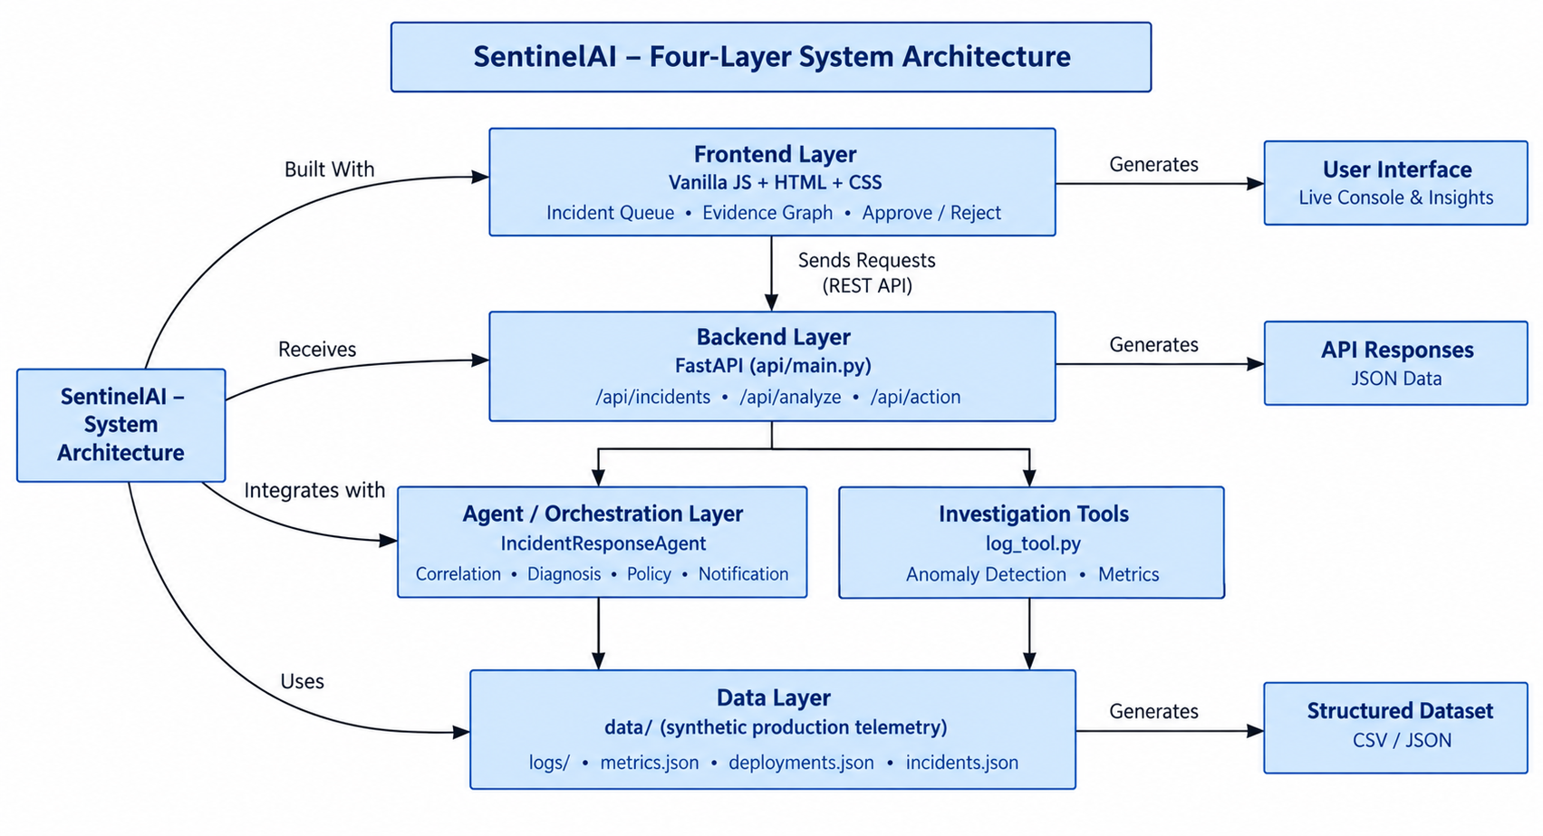

Description:
The application follows a four-layer architecture. The frontend is a dependency-free HTML/CSS/vanilla-JavaScript command-center dashboard (ui/index.html, app.js, styles.css) that polls the backend for incidents, decisions, and policy state and renders an incident queue, an evidence trail, a telemetry graph, and a live SRE rollout console. The FastAPI backend (api/main.py) exposes the full incident lifecycle under /api, registers permissive CORS middleware, seeds four realistic demonstration incidents on startup, and mounts the UI directory as static files so the whole application is served from a single FastAPI process.
Underneath the API sits the IncidentResponseAgent (agent/agent.py), which orchestrates the CorrelationEngine, the GroqDiagnosisAgent, the PolicyEngine, and the NotificationDispatcher. When an alert comes in, the agent queries three investigation tools — log_tool.py, deploy_tool.py, and metrics_tool.py — against the synthetic telemetry in /data, runs the CorrelationEngine's deterministic signature matching (or, when a GROQ_API_KEY is configured, a Groq Llama 3.1 70B tool-calling loop following the same five-stage protocol), and constructs a structured Incident with log, deploy, and metric evidence plus a proposed RemediationAction. Every proposed action is evaluated by the PolicyEngine against confidence thresholds, risk tiers, and a database-migration safety guardrail before it can ever be auto-executed.

Pre-requisites:
- Python Programming Proficiency: Python Documentation
- FastAPI & Pydantic Familiarity: FastAPI Documentation
- Groq API & Tool-Calling Familiarity: Groq API Documentation
- SRE Concepts — Root Cause Analysis & Incident Response: Google SRE Book
- JavaScript, HTML & CSS Fundamentals: MDN Web Docs
- Pytest Testing Framework: Pytest Documentation
- Version Control with Git: Git Documentation

Project Workflow:

Milestone 1: Model Selection and Architecture
- Activity 1.1: Configure environment secrets (.env) for Groq API credentials and public tunnel access.
- Activity 1.2: Research and select the diagnostic orchestration approach — the five-stage protocol, tool-calling loop, and policy-gated safety model.
- Activity 1.3: Define the architecture of the application, detailing interactions between the frontend, FastAPI backend, agent/orchestration layer, and the synthetic telemetry data layer.
- Activity 1.4: Set up the development environment, installing backend dependencies and preparing the synthetic incident dataset.

Milestone 2: Core Functionalities Development
- Activity 2.1: Develop the core functionalities: the Correlation Engine, the Groq Diagnosis Agent, the Policy Engine, and the Notification Dispatcher.
- Activity 2.2: Implement the FastAPI backend to manage incident investigation, action approval, policy configuration, and tool inspection endpoints.

Milestone 3: App.py Development
- Activity 3.1: Write the main application logic in api/main.py, establishing the FastAPI instance, CORS middleware, startup incident seeding, and API routes.

Milestone 4: Frontend Development
- Activity 4.1: Design and develop the SRE AgentAI command-center dashboard using HTML, CSS, and vanilla JavaScript.
- Activity 4.2: Create dynamic data fetching, approval workflows, and the live rollout console that connect every dashboard view to the live FastAPI backend.

Milestone 5: Deployment
- Activity 5.1: Prepare the application for local deployment by configuring the server environment and ensuring all dependencies are correctly installed.
- Activity 5.2: Deploy the application publicly using Ngrok.

Milestone 6: Conclusion

Milestone 1: Model Selection and Architecture
In this milestone, the focus is on selecting the right diagnostic and safety-orchestration approach for an autonomous incident-response agent, and defining the project's overall system architecture. This involves evaluating how a five-stage forensic protocol, a Groq tool-calling loop, and a three-mode policy engine can work together to keep every proposed remediation fast, explainable, and safe, while ensuring the chosen design aligns with the project's core promise: the agent investigates and proposes, but a human — or an explicit, auditable policy — always decides.

Activity 1.1: Configure Environment Secrets and API Credentials
Before the diagnosis agent can reach the Groq API (or run entirely on its deterministic fallback), the project needs a set of environment variables. Follow the steps below to set them up.
- Step 1 — Create the Environment File: Create a .env file at the project root to hold the Groq credentials.
# .env
- Step 2 — Configure the Groq Provider: GROQ_API_KEY and GROQ_MODEL point the diagnosis agent at Groq's llama-3.1-70b-versatile model; GROQ_TIMEOUT and GROQ_MAX_RETRIES tune request resilience. Leaving GROQ_API_KEY unset is fully supported — the agent automatically falls back to its deterministic forensic correlation engine.
GROQ_API_KEY=your_groq_api_key_here
GROQ_MODEL=llama-3.1-70b-versatile
GROQ_TIMEOUT=30
GROQ_MAX_RETRIES=3
- Step 3 — Configure the Public Tunnel (Optional): NGROK_URL and NGROK_AUTH_TOKEN hold the credentials used later, in Milestone 5, to expose the dashboard on a public URL.
NGROK_URL="https://your-subdomain.ngrok-free.dev"
NGROK_AUTH_TOKEN="your_ngrok_auth_token_here"
- Step 4 — Verify the Settings Load Automatically: diagnosis_agent.py calls load_dotenv() at import time, so GROQ_API_KEY and GROQ_MODEL are available the moment the GroqDiagnosisAgent is constructed.
from dotenv import load_dotenv
load_dotenv()
self.api_key = api_key or os.environ.get("GROQ_API_KEY")
self.model = model or os.environ.get("GROQ_MODEL", "llama-3.1-70b-versatile")
- Important — Never Commit Secrets: Keep .env out of version control and rotate any key or token that was ever committed to a shared file.

Activity 1.2: Research and Select the Orchestration Approach
- Understand the Project Requirements: Review the system's needs — correlating logs, deployments, and metrics into a single root-cause diagnosis, and proposing (never silently executing) a remediation.
- Adopt the Five-Stage Diagnostic Protocol: Encode telemetry extraction, mandatory alternative-explanation checking (resource exhaustion, vendor outages, expired certificates, deadlocks), deploy-causality-vs-red-herring validation, evidence citation, and structured JSON output as the fixed reasoning sequence both the Groq agent and its deterministic fallback follow.
- Evaluate the Tool-Calling Loop: Assess a bounded, five-turn Groq chat-completions loop with three function tools — read_logs, get_deploy_history, get_metrics — as the only way the LLM can gather evidence, with a deterministic CorrelationEngine as a drop-in replacement whenever no Groq key is configured or a call fails.
- Select the Safety-Orchestration Design: Adopt a three-mode PolicyEngine (MANUAL, AUTONOMOUS, TIMED_FALLBACK) with confidence-threshold, risk-tier, and database-migration-keyword guardrails as the single gate every proposed action must pass before it can ever auto-execute.

Activity 1.3: Define the Architecture of the Application
- Draft an Architectural Diagram: Create a visual representation of the four layers — the vanilla-JS frontend, FastAPI backend, agent/orchestration layer, and the synthetic telemetry data layer — as shown above.
- Detail Frontend Functionality: Outline how operators interact with the app: browsing the incident queue, reviewing the evidence trail and telemetry graph for a selected incident, approving or rejecting a proposed action, watching the live SRE rollout console, and toggling Night Mode.
- Outline Backend Responsibilities: Specify how the FastAPI backend exposes /api/incidents, /api/incidents/analyze, /api/incidents/{id}, /api/incidents/{id}/action, /api/agent/diagnose, /api/decisions, /api/policy, /api/incidents/{id}/start-timer, /api/incidents/{id}/pause-timer, /api/notifications, and the direct /api/tools/* inspection routes.
- Describe AI Integration Points: Define how an incoming alert flows through investigate() into the CorrelationEngine or GroqDiagnosisAgent, how the resulting RemediationAction is evaluated by the PolicyEngine, and how approval — human or policy-driven — is the only path to handle_action() actually executing anything.

Activity 1.4: Set Up the Development Environment
- Install Python: Ensure Python 3.10+ is installed on the machine.
- Create a Virtual Environment: Isolate project dependencies using venv.
python -m venv venv
# Windows (PowerShell): .\venv\Scripts\Activate.ps1
# macOS/Linux: source venv/bin/activate
pip install -r requirements.txt
- Project Dependencies: requirements.txt pins fastapi, uvicorn[standard], pydantic, python-dateutil, pytest, requests, groq, and python-dotenv — everything the API, agent, and evaluation suite need.
- Application Structure: The project is organized as agent/ (models, correlation engine, diagnosis agent, policy engine, orchestrator), tools/ (log, deploy, metrics, notification tools), api/ (the FastAPI app), ui/ (the command-center dashboard), data/ (synthetic logs, deployments, and metrics), and eval/ (pytest suites and a scenario-based benchmark runner).
- Deterministic Synthetic Data: data/logs/*.log, data/deployments.json, and data/metrics.json hold hand-crafted, realistic telemetry for four demonstration incidents — a CrowdStrike kernel panic, a Cloudflare regex catastrophe, a checkout NullPointerException, and a Stripe vendor outage — so every walkthrough of the agent is fully reproducible with no external services required.

Milestone 2: Core Functionalities Development
Milestone 2 builds out the core functional modules of the system and the FastAPI backend that powers them, turning the architecture defined in Milestone 1 into a working, evidence-driven incident-response agent.

Activity 2.1: Develop the Core Functionalities
- Correlation Engine: CorrelationEngine.analyze() (agent/correlation_engine.py) cross-references error logs, deployment timing, and metric anomalies, classifies the incident against six root-cause signatures — memory exhaustion, connection-pool exhaustion, CPU/thread starvation, external vendor outages, expired certificates, and deadlocks — before ever attributing an incident to a deployment, and returns severity, evidence objects, a RootCauseAnalysis, and a proposed RemediationAction.
- Groq Diagnosis Agent: GroqDiagnosisAgent.diagnose() (agent/diagnosis_agent.py) runs a bounded five-turn Groq tool-calling loop against the same five-stage protocol when an API key is configured, and transparently falls back to _run_deterministic_diagnosis() — the same signature-matching logic as the CorrelationEngine — when it isn't, or when the Groq call raises an exception.
- Investigation Tools: log_tool.py parses structured, multi-line stack-trace log entries with a fixed regex grammar; deploy_tool.py queries deployment history, commit hashes, and rollback versions; metrics_tool.py loads CPU, memory, error-rate, and latency time series and flags statistical anomalies against a rolling baseline.
- Policy Engine: PolicyEngine.evaluate_action() (agent/policy_engine.py) checks a proposed action's confidence score against the configured threshold, its risk level against the allowed tiers, and its deployment diff against a list of unsafe-change keywords (migration, schema, drop table, secret, and more) before it will ever return can_execute=True for AUTONOMOUS or TIMED_FALLBACK modes.
- Notification Dispatcher: NotificationDispatcher.dispatch() (tools/notification_tool.py) simulates pushing PagerDuty and Slack escalation alerts — with quick-approve and quick-reject URLs — the moment an incident produces a proposed action, and keeps a queryable history of every notification sent.
- Human-in-the-Loop Approval & Audit: IncidentResponseAgent.handle_action() (agent/agent.py) is the single choke point where a proposed action becomes APPROVED, REJECTED, or EXECUTED — the agent never bypasses it — and every decision is appended to a structured DecisionRecord audit trail.

Activity 2.2: Implement the FastAPI Backend
- Define the API Surface: api/main.py declares one FastAPI() app exposing the full incident lifecycle: listing, analyzing, retrieving, and acting on incidents; querying the audit log and policy configuration; starting or pausing an auto-remediation countdown; and directly inspecting the logs, deployments, and metrics tools.
- Enforce CORS: api/main.py registers CORSMiddleware with allow_origins=["*"] so the statically-served command-center UI can call every route without extra configuration.
app = FastAPI(
title="Incident Response Agent Service",
description="Autonomous Agent for triage, root cause correlation, and automated remediation approvals.",
version="1.0.0",
)
app.add_middleware(
CORSMiddleware,
allow_origins=["*"], allow_credentials=True,
allow_methods=["*"], allow_headers=["*"],
)
- Serve the UI from the Same Process: The ui/ directory is mounted at /static and the root route ("/") serves ui/index.html directly, so the entire dashboard ships from a single FastAPI process with no separate frontend server.
- Direct Tool Inspection Endpoints: /api/tools/logs, /api/tools/deployments, and /api/tools/metrics expose the same investigation tools the agent itself uses, so an engineer can query raw telemetry directly for debugging without triggering a full investigation.

Milestone 3: App.py Development
Milestone 3 focuses on the application entry point that serves as the backbone of the backend — api/main.py. In this milestone, the FastAPI instance is created, CORS is registered, demonstration incidents are seeded on startup, and every investigation, approval, and policy route is wired to the shared agent_instance singleton.

Activity 3.1: Writing the Main Application Logic in main.py
- Instantiate the Agent Singleton: agent/agent.py builds a module-level agent_instance = IncidentResponseAgent() at import time, so every route handler in api/main.py shares one running agent, policy configuration, and audit log.
- Seed Demonstration Incidents on Startup: An @app.on_event("startup") handler resets the policy to MANUAL and, if no incidents exist yet, investigates the four canonical demo scenarios — CrowdStrike, Cloudflare, checkout-service, and payment-gateway — so the dashboard is populated the instant the server comes up.
@app.on_event("startup")
def startup_event():
agent_instance.policy_engine.update_policy(mode=PolicyMode.MANUAL)
if not agent_instance.list_incidents():
agent_instance.investigate(
service_name="checkout-service",
title="\U0001F6D2 CRITICAL: 5xx Error Rate Spike...",
description="...",
)
- Expose the Investigation & Approval Lifecycle: POST /api/incidents/analyze triggers a fresh investigation for a named service; POST /api/incidents/{id}/action is the sole route that approves or rejects a proposed RemediationAction — the agent itself never calls this on its own outside an explicit policy rule.
@app.post("/api/incidents/{incident_id}/action", response_model=RemediationAction)
def take_action(incident_id: str, req: ActionDecisionRequest):
return agent_instance.handle_action(
incident_id=incident_id, action_id=req.action_id,
approve=req.approve, reviewer=req.reviewer,
)
- Expose Policy Control: GET/POST /api/policy read and update the AutoRemediationPolicy — including switching to TIMED_FALLBACK, which automatically arms a countdown on every currently-proposed action — and POST /api/incidents/{id}/start-timer and .../pause-timer let an operator arm or cancel the dead man's switch on one specific incident.
- Ground the AI Diagnosis Endpoint: POST /api/agent/diagnose calls agent_instance.diagnose_alert(), which tries Groq first and transparently falls back to the deterministic forensic engine, returning a structured DiagnosisReport with cited evidence and a confidence score.
- Automatic API Documentation: Because every route is a plain FastAPI endpoint, FastAPI generates a live, interactive Swagger UI at /docs and a ReDoc view at /redoc with zero extra configuration.

Milestone 4: Frontend Development
Milestone 4 focuses on building the SRE AgentAI command-center dashboard — a dependency-free HTML, CSS, and vanilla JavaScript single-page application — and wiring every one of its panels to live data from the FastAPI backend.

Activity 4.1: Designing and Developing the User Interface
- Build the Incident Queue: A searchable, filterable incidentsList sidebar shows every tracked incident with a severity badge and a live queueBadge count, so an on-call engineer can immediately see how many incidents need attention.
- Build the Incident Detail Panel: The incidentMain panel shows the incident title, subtitle (ID, detection time, service), a confidence bar, and an evidenceTrail summarizing the log, deploy, and metric findings that produced the diagnosis.
- Render the Telemetry Graph: An inline SVG telemetrySvg chart plots the relevant metric time series around the incident window, with a hoverable graphTooltip for inspecting exact values at any point.
- Build the Proposed Fix & Approval Panel: actionCommand shows the exact command preview for the proposed remediation, with Approve and Reject buttons wired to submitActionDecision(), plus a countdownBanner that appears only when a TIMED_FALLBACK deadline is armed on that incident.
- Build the Live SRE Rollout Console: Once an action is approved, the sreConsole streams the simulated kubectl rollout — replica readiness, liveness/readiness probes, and the canary error-rate and latency drop — line by line, with a live probesPassed and errorDelta summary in the console footer.

Activity 4.2: Creating Dynamic Content Rendering
- Poll for Live State: app.js polls /api/incidents, /api/decisions, and /api/policy on an interval so the incident queue, audit trail, and Night Mode label all stay current without a page refresh or a WebSocket connection.
- Trigger New Investigations from the UI: The New Investigation modal posts a service name and description to /api/incidents/analyze and immediately renders the resulting incident, evidence trail, and any proposed action.
- Wire the Approval Workflow: submitActionDecision(true | false) posts to /api/incidents/{id}/action with the reviewer's identity, then refreshes the incident detail panel, the audit trail, and — on approval — kicks off the SRE console's simulated rollout playback.
- Toggle Night Mode Live: togglePolicyMode() posts to /api/policy to flip between MANUAL and TIMED_FALLBACK, updating the nightModeLabel and re-arming countdowns on any currently-proposed actions.
- Render Escalations & Audit History: The escalation modal lists every PagerDuty/Slack notification from /api/notifications, and the full-details modal renders the complete decision_history, root-cause analysis, and evidence payload for any incident on demand.

Milestone 5: Deployment
In Milestone 5, the focus is on deploying the application first locally to verify correct operation, and then publicly via Ngrok to share the command-center dashboard over a secure, accessible URL. This involves configuring the server environment, managing Python dependencies, and launching the single FastAPI process for real-world use.

Activity 5.1: Preparing the Application for Local Deployment
- Set Up a Virtual Environment and Install Dependencies:
python -m venv venv
.\venv\Scripts\Activate.ps1 # Windows PowerShell
source venv/bin/activate # macOS/Linux
pip install -r requirements.txt
- Configure Environment Variables: Create a .env file in the project root with a Groq API key if live AI-powered diagnosis is wanted; the app loads this automatically with python-dotenv at start-up and otherwise runs entirely on its deterministic forensic engine.
GROQ_API_KEY=your_groq_api_key_here
GROQ_MODEL=llama-3.1-70b-versatile
- Start the Server: A single uvicorn process serves both the API and the static command-center UI.
python -m uvicorn api.main:app --reload --host 0.0.0.0 --port 8000
- Access the Application: Dashboard at http://localhost:8000, interactive API docs at http://localhost:8000/docs, and the raw incident feed at http://localhost:8000/api/incidents.

Activity 5.2: Public Deployment via Ngrok
Ngrok creates a secure tunnel from a public URL to your local FastAPIserver, making the app accessible from anywhere without a cloud hosting provider.
Install Ngrok and pyngrok:
- Install the pyngrok Python wrapper, which manages Ngrok programmatically within your Python project:
pip install pyngrok
- Download and install the Ngrok client from https://ngrok.com/download.
- Click on “Microsoft Store Installer”.
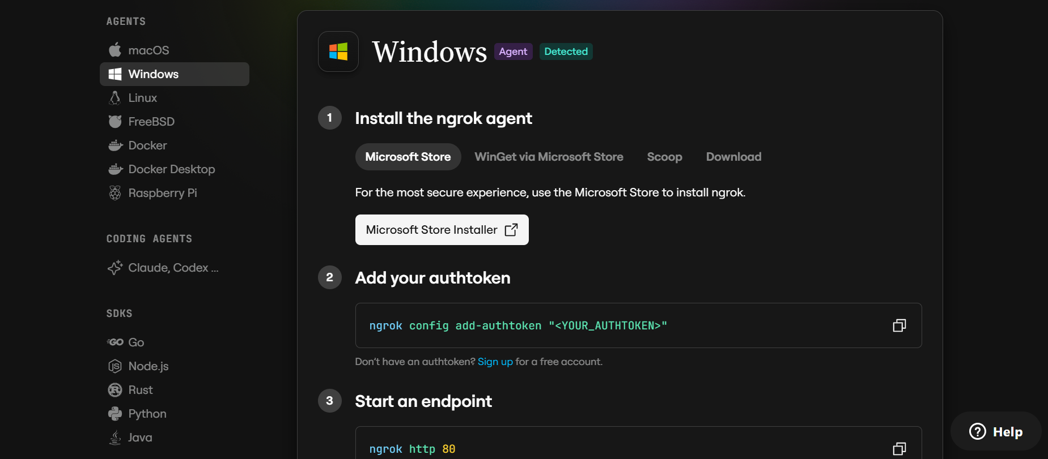
Configure Your Ngrok Authtoken:
- Sign up at ngrok.com and copy your authtoken from the Ngrok dashboard.
- The run_public.py script sets the authtoken automatically using:
D:\projects>ngrok.set_auth_token("YOUR_NGROK_AUTHTOKEN")
- Replace the TOKEN value in run_public.py with your own Ngrok authtoken before running.

Run the Public Deployment Script:
- Instead of running app.py directly, launch run_public.py to start both the Ngrok tunnel and the Flask server:
D:\projects>python run_public.py
- The script opens an HTTP tunnel on port 5000 and prints the live public URL in the terminal:
======================================================
YOUR PUBLIC WEBSITE URL IS LIVE!
URL: https://xxxx-xx-xx-xxx-xx.ngrok-free.app
======================================================
- Share this URL with anyone who can access your CaptionAI app directly from their browser without any installation.

Important Notes:
- debug=False is required in run_public.py to prevent Flask from spawning a reloader process, which would interfere with Ngrok’s tunnel management.
- The public URL changes each time you restart run_public.py (on the free Ngrok plan). For a persistent URL, upgrade to a paid Ngrok plan and configure a reserved domain.
- Ngrok free tier sessions expire after a few hours of inactivity. Restart run_public.py to get a new URL when this happens.

Exploring the Webpages :

Incident Queue:
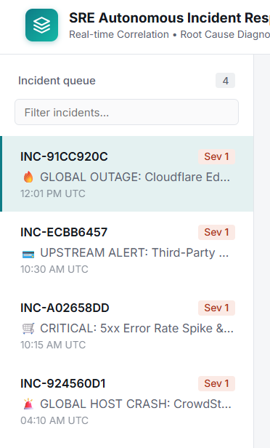

Description: The left-hand sidebar and the dashboard's entry point. It lists every tracked incident with a severity badge, a live count badge, and a search box for filtering by service or title, so an on-call engineer can immediately see how many incidents are open and which need attention first.

Incident Detail Panel:
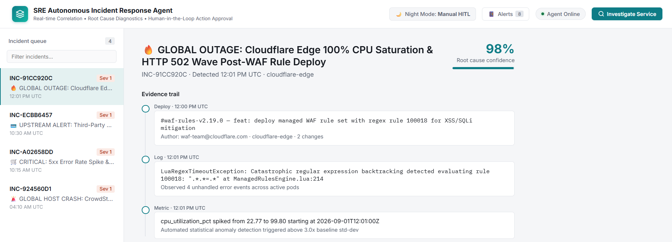

Description: The main panel for a selected incident: title, subtitle (incident ID, detection time, service), a confidence bar showing the diagnosis's confidence score, and an evidence trail summarizing the log, deployment, and metric evidence that produced the root-cause analysis.

Telemetry Graph:
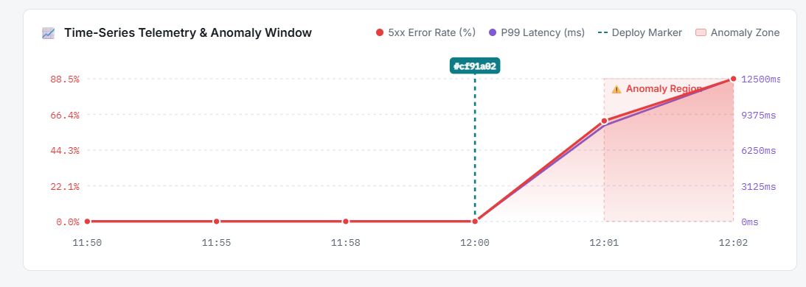

Description: An inline SVG chart plotting the relevant metric — error rate, latency, CPU, or memory — around the incident window, with a hoverable tooltip for inspecting the exact value at any point on the curve.

Proposed Fix & Approval:
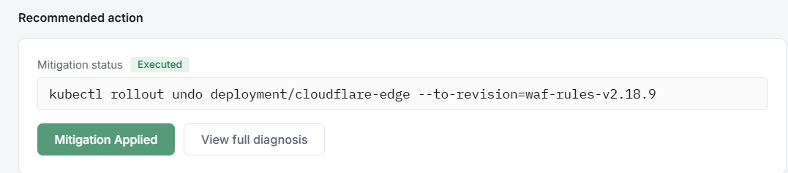
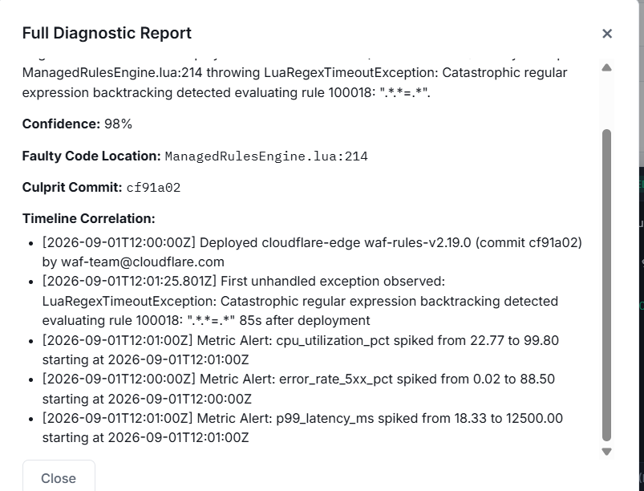
Description: Shows the exact command preview for the agent's proposed remediation — a rollback, scale-up, throttle, or circuit-breaker activation — with Approve and Reject buttons. When TIMED_FALLBACK is armed on the incident, a countdown banner appears showing how long remains before the dead man's switch auto-executes the action.

SRE Rollout Console:
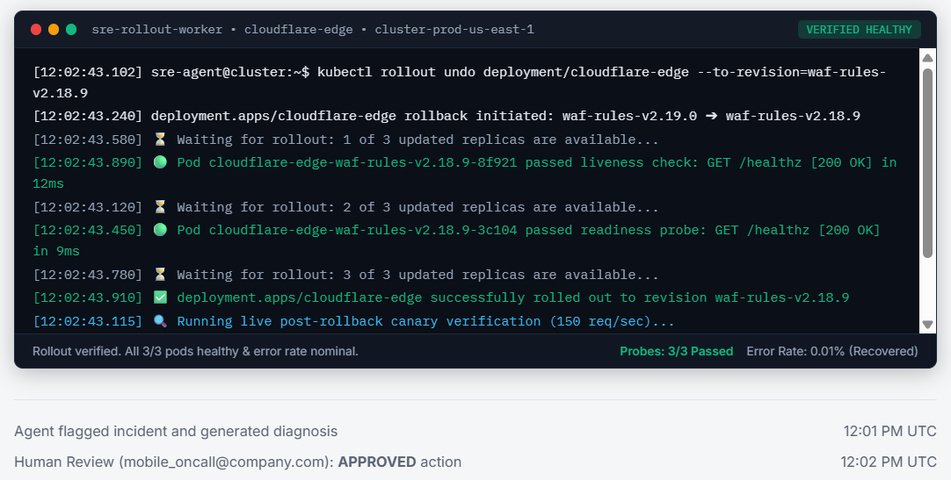

Description: Appears the moment an action is approved and streams the simulated kubectl rollout line by line — replica readiness, liveness and readiness probes, and the canary error-rate and P99 latency drop back to nominal — with a live probes-passed and error-delta summary in the footer.

Night Mode / Policy Toggle:
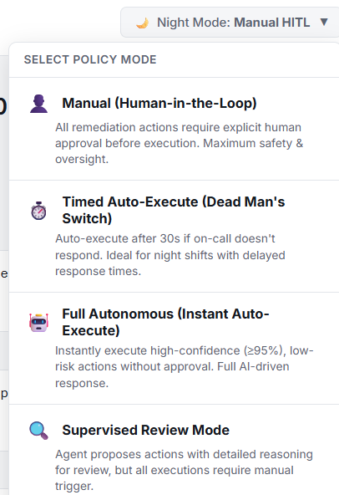

Description: A topbar control that switches the Policy Engine between MANUAL (Human-in-the-Loop, default) and TIMED_FALLBACK (dead man's switch), labeled live from /api/policy so every operator sees the same current safety mode.

New Investigation & Escalation Modals:
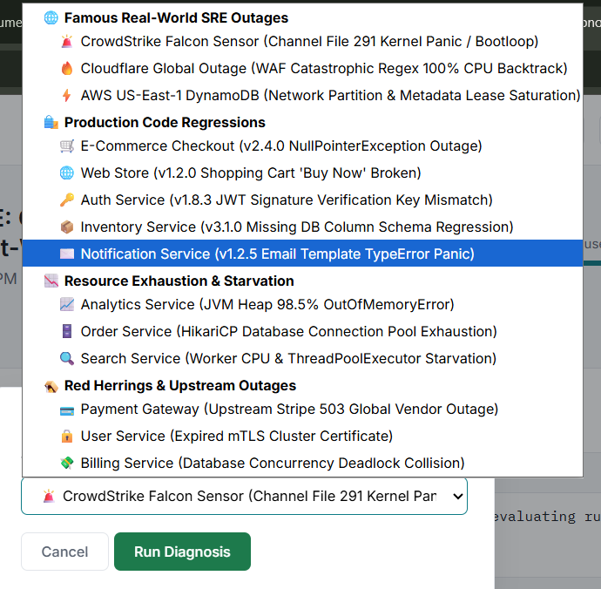
Description: The New Investigation modal lets an operator manually trigger investigate() for any named service; the Escalation modal lists every simulated PagerDuty and Slack notification the system has dispatched, each with its quick-approve and quick-reject mobile URLs.

Conclusion:
SRE AgentAI is an autonomous SRE incident-response agent built with FastAPI, a deterministic multi-signal correlation engine, and an optional Groq Llama 3.1 tool-calling diagnosis loop. It turns raw production telemetry — logs, deployments, and metrics — into a cited, confidence-scored root-cause diagnosis in seconds, explicitly rules out false-positive deployment blame before proposing a rollback, and routes every proposed fix through a configurable Policy Engine that keeps a human, or an explicit and auditable safety rule, in control of what actually executes.
The project, which spanned diagnostic protocol design, a deterministic correlation and Groq-backed reasoning core, a policy-gated human-in-the-loop approval workflow, and a real-time vanilla-JavaScript command-center frontend, demonstrates how a disciplined, evidence-first reasoning pipeline combined with strict safety guardrails can support real on-call decision-making without ever taking the human fully out of the loop. Looking ahead, the platform is positioned to grow from its current synthetic-telemetry demonstration into a system wired to genuine log aggregators, deployment platforms, and metrics providers, to add WebSocket-based real-time updates in place of polling, and to extend the policy engine and notification dispatcher to real PagerDuty, Slack, and Kubernetes integrations — evolving it from a demonstration platform into a validated, production-grade autonomous SRE teammate.

